Networks in R

# Project 1

## Task 1

The network of relations between 28 girls as shown in Moreno’s sociogram (C11, the page 273) has been manually encoded in the Pajek format.

The results is presented with three files:

1. Moreno_C11.ini – the Pajek initialization file.
2. Moreno_C11.net – the network description in the Pajek format.
3. Moreno_C11.jpg – the network visualization in JPEG, also pasted below (Figure 1.1).

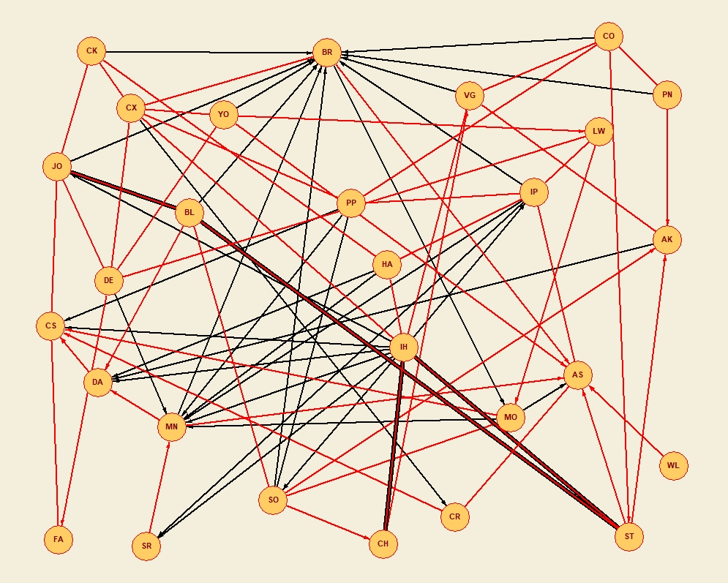

Figure 1.1. Moreno’s sociogram - C11

During the exercise the following assumptions and transformations were undertaken:

1. “Attraction” and “Mutual Attraction” are considered as the same type of relation (link) with two cases: a directed link (an arc) and undirected link (an edge), correspondingly. This type of link is coded with **3** in the Pajek network, and is visualized with the **red** line.
2. Likewise the previous item, “Repulsion” and “Mutual Repulsion” are considered as the same type of relation (link) with two cases: a directed link (an arc) and undirected link (an edge), , correspondingly. This type of link is coded as **1** in the Pajek network, and is visualized with the **black** line.

So, the link coding schema for the network is as follows

|  |  |  |  |
| --- | --- | --- | --- |
| **Relation No** | **Arc** | **Edge** | **Line Color** |
| **1** | Repulsion | Mutual Repulsion | **Black** |
| **3** | Attraction | Mutual Attraction | **Red** |

1. There are vertices with multiple links between them, namely, there are vertices with both “Mutual Attraction” and “Mutual Repulsion” between them: BL and JO, IH and ST, CH and IH. So the network is the multi-relational one. Pajek does not support drawing multiple relations between two vertices in the same way as shown on the original diagram. Therefore, such relations are drawn by a thick black line (“Mutual Repulsion”) with a thin red line within (“Mutual Attraction”).

Table 1.1. Basic Properties

|  |  |
| --- | --- |
| **Property** | **Value** |
| Vertices, number | 28 |
| Edges, number | 84 |
| Vertex type | Person |
| Edge type | Emotional relation |
| Edge weights? | No |
| Average degree | 6 |
| Diameter | 7 |
| Acyclic? | FALSE |

Initial findings from observing the network:

1. The network provides information about relations of two types: “(mutual) attraction” (meaning “do like”) and “(mutual) repulsion” (meaning “do not like”) between 28 girls living in proximity, probably, sharing the same house. The number of relations between the girls:

**Relation No. Arcs Edges Total Label**

--------------------------------------------------------------------

1 29 5 34 repulsion

3 21 29 50 attraction

--------------------------------------------------------------------

1. The “attraction” relation is much more frequent in the mutual form than the “repulsion” one. From the other end, the directed relation is more frequent with “repulsion” than with “attraction”. That might mean the “repulsion” feeling is not usually shared between two girls in the population i. e. it’s usually a ”directed” feeling.
2. There are pairs which have both the “mutual attraction” and “mutual repulsion” relations. That might mean these pairs are sometimes friends and are sometimes rather not, so there is some instability in feelings between them.
3. There are different patterns of relations e. g.
   1. Girls with four and less relations in total, i. e. they don’t have many of them, have more the “attraction” relations than the “repulsion” ones (zero or just one of it), those are AK, BL, CH, CK, CR, FA, LW, PN, WL. It might mean several mutually exclusive things e. g. a) the girls are friendly persons who do not try to build many relations but rather value a few of them, b) they did not report of any other relations, probably, hided problems with some other girls.
   2. There are girls which tend to have mostly the “repulsion” relations towards them. BR, MN. There must be some reasons for that, they are probably mischievous or they are envied.
   3. IH mostly repulses the others. She probably needs a therapy to avoid growing into an sullen woman.
   4. FA, WL seem to have difficulties to make relations or they do not probably need more than just one or two relations.
   5. AS looks like a very positive person: seven “attractions” vs just one “repulsion”.

In overall, the network has more positive “attraction” links and negative “repulsion” links which a good indication for this small society.

Ideas for further analysis:

1. Identify clusters with the k-core method.
2. Identify similar nodes in terms their links (quantity and quality) to other nodes. Might any identify similar psychological types in this way?

## Task 2

The network given in the “as6.net“ has been redrawn in Pajek, it’s saved back in the same file along with the initialization file names “as6.ini”. The static visualization is saved as “as6.jpg”.

The network was presumably built on the basis of answers to the following question

*From whom would you borrow small amount of money (e.g. 20 EUR)?*

*Choose as many students as you wish.*

The redrawn graph of the network is shown on Figure 2.1.

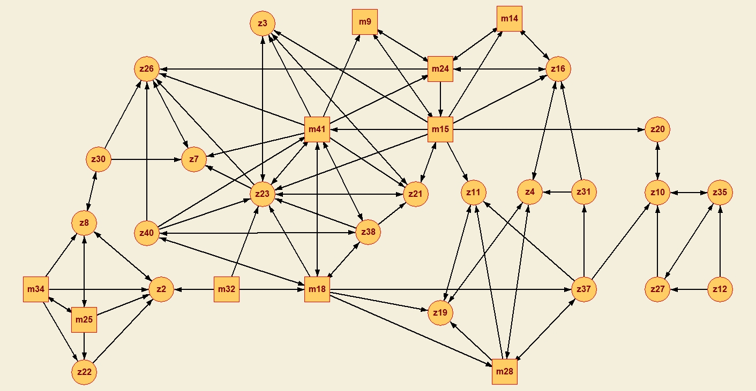

Figure 2.1. The graph of “From whom would you borrow small amount of money?”

Let’s assume the link“s direction towards a person means “I’d borrow from...” for that person e. g. for the pair z27 and z12 the link means z27 would borrow small amount of money from z12.

Table 2.1. Basic Properties

|  |  |
| --- | --- |
| **Property** | **Value** |
| Vertices, number | 32 |
| Edges, number | 103 |
| Vertex type | Person of two partitions (man, woman) |
| Edge type | The intention “I’d borrow from...” |
| Edge weights? | No |
| Average degree | 6.4 |
| Diameter | 8 |
| Acyclic? | No, e. g. there is a cycle z27 - z10 – z35 |

That’s interesting to note that

1. There are m-nodes and z-nodes so we may think the network has two partitions.
2. There are ‘outer’ subnetworks (in the left bottom and on the right side of the picture), they consists of nodes.
3. The ‘centeral’ area of network seems to be around the nodes z23 and m41. Visually, they have the highest number of degrees (links).
4. The “I’d borrow from...” feeling is not always mutual. It’s probably more often the one-way one than two-ways.
5. There are two persons with high in-degree values: z26 and z23. Are they prospective diplomats? :)

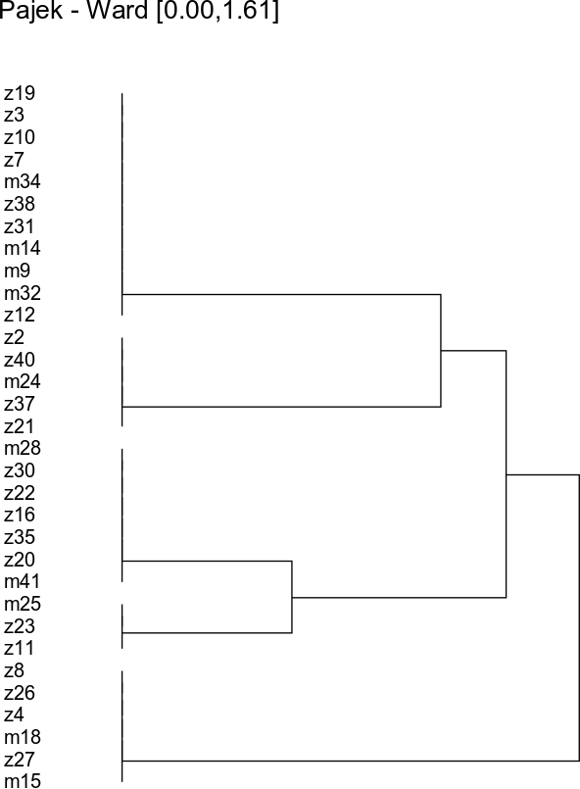

Figure 2.2. Cluster dendrogram (Ward)

## Project 2

See the report in the file “Project 2 - Wiki Norms/wiki_norms.pdf“

## Project 3

See the report in the file “Project 3 - CRAN Dependencies/cran_dep.pdf”